Topics covered

1) Equivalence of NFA and DFA

2) Converting epsilon NFA to DFA

3) Converting epsilon NFA to NFA

**Equivalence of NFA and DFA  
 (Construct a equivalent DFA from a given NFA)**

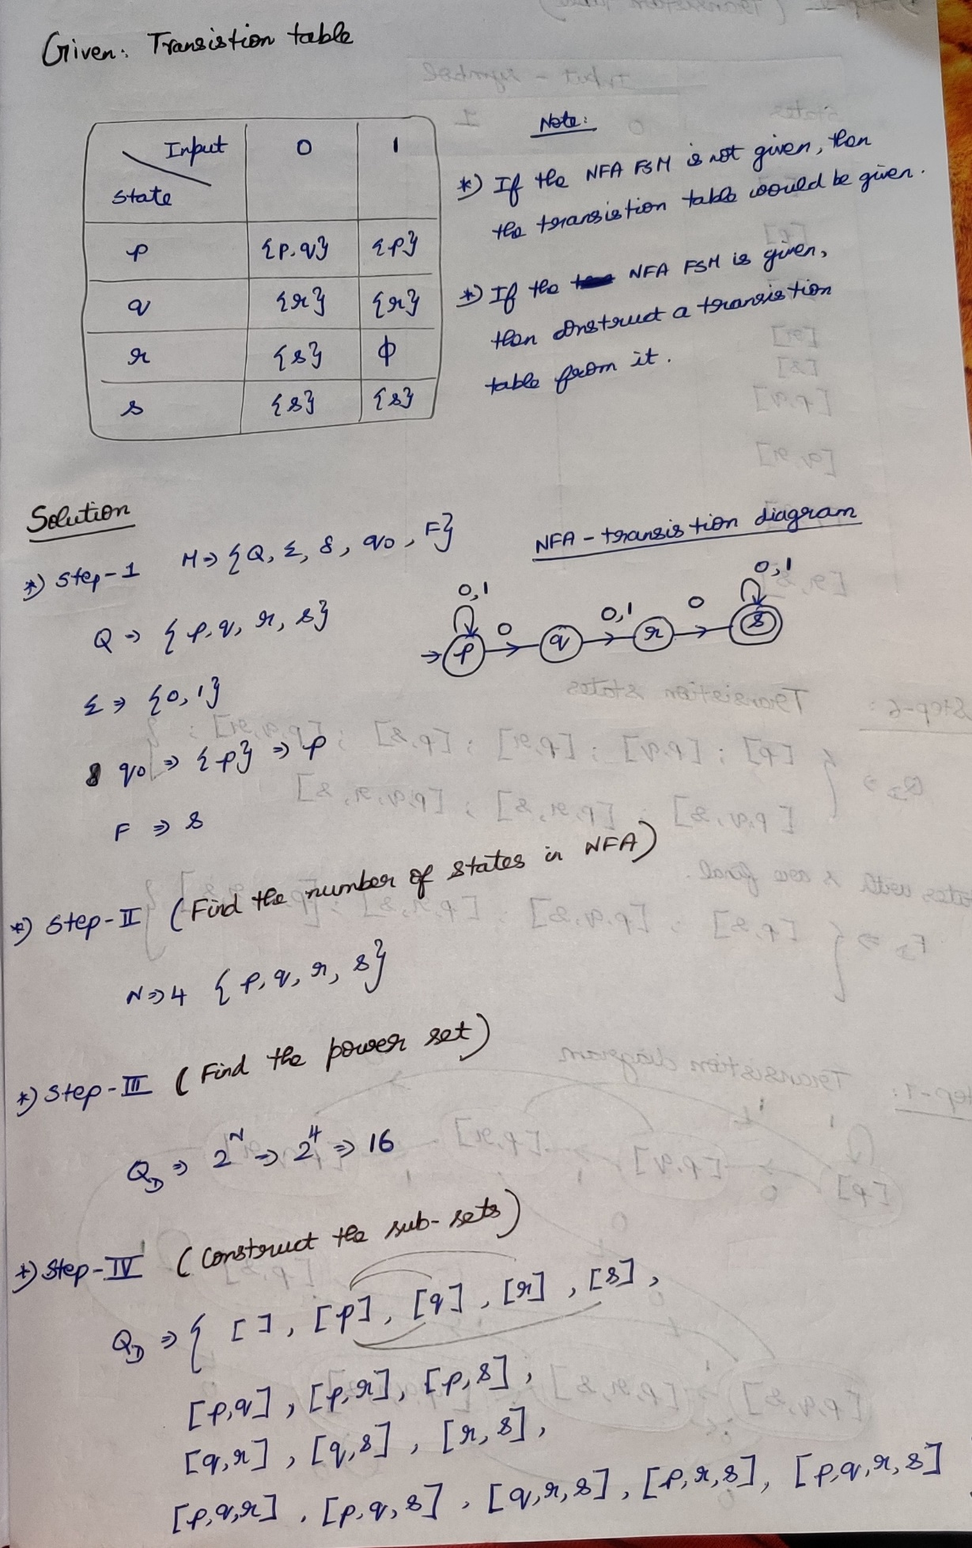

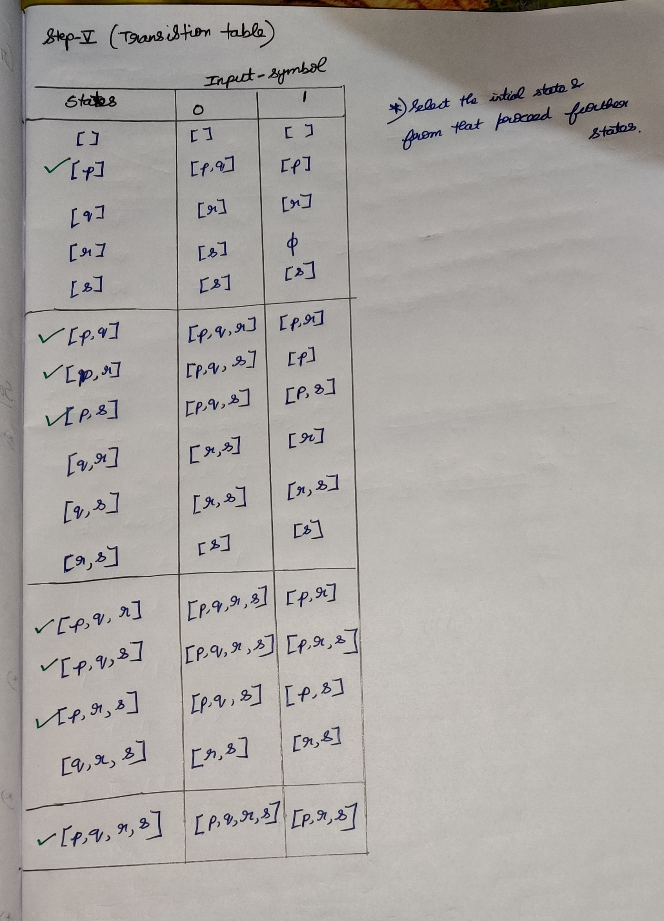

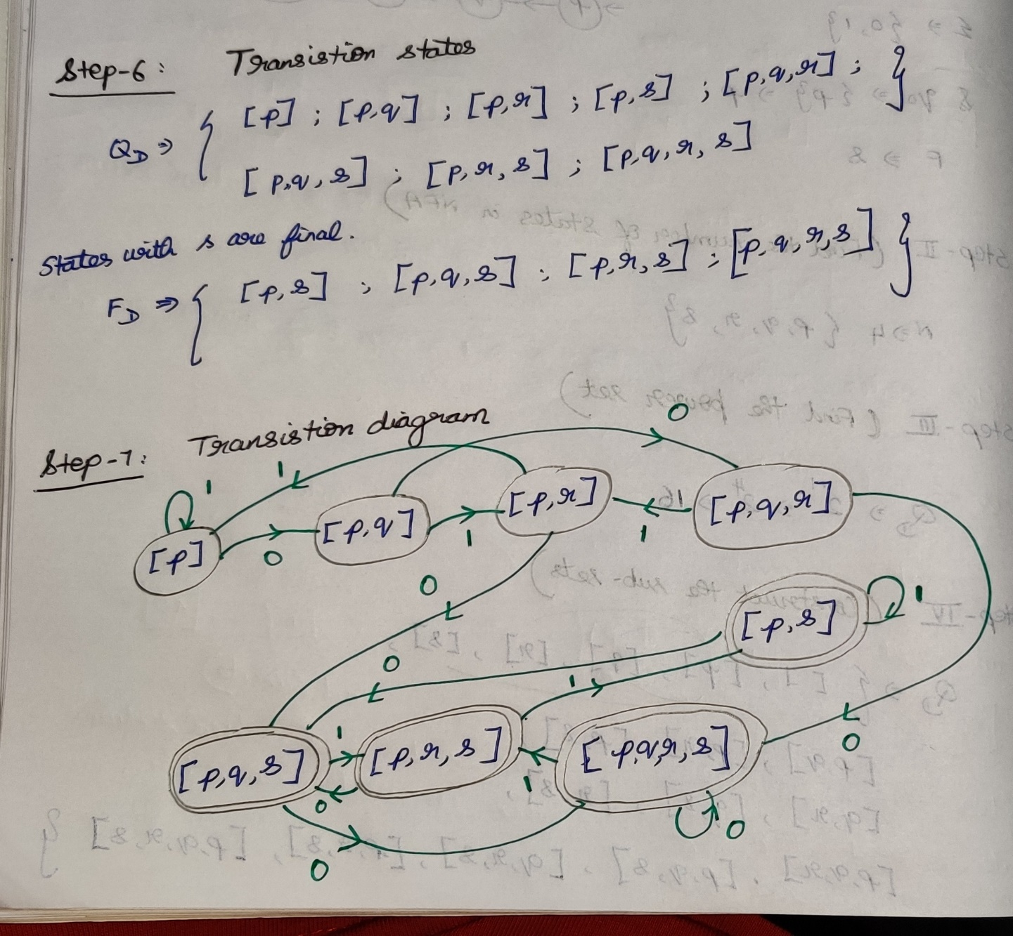

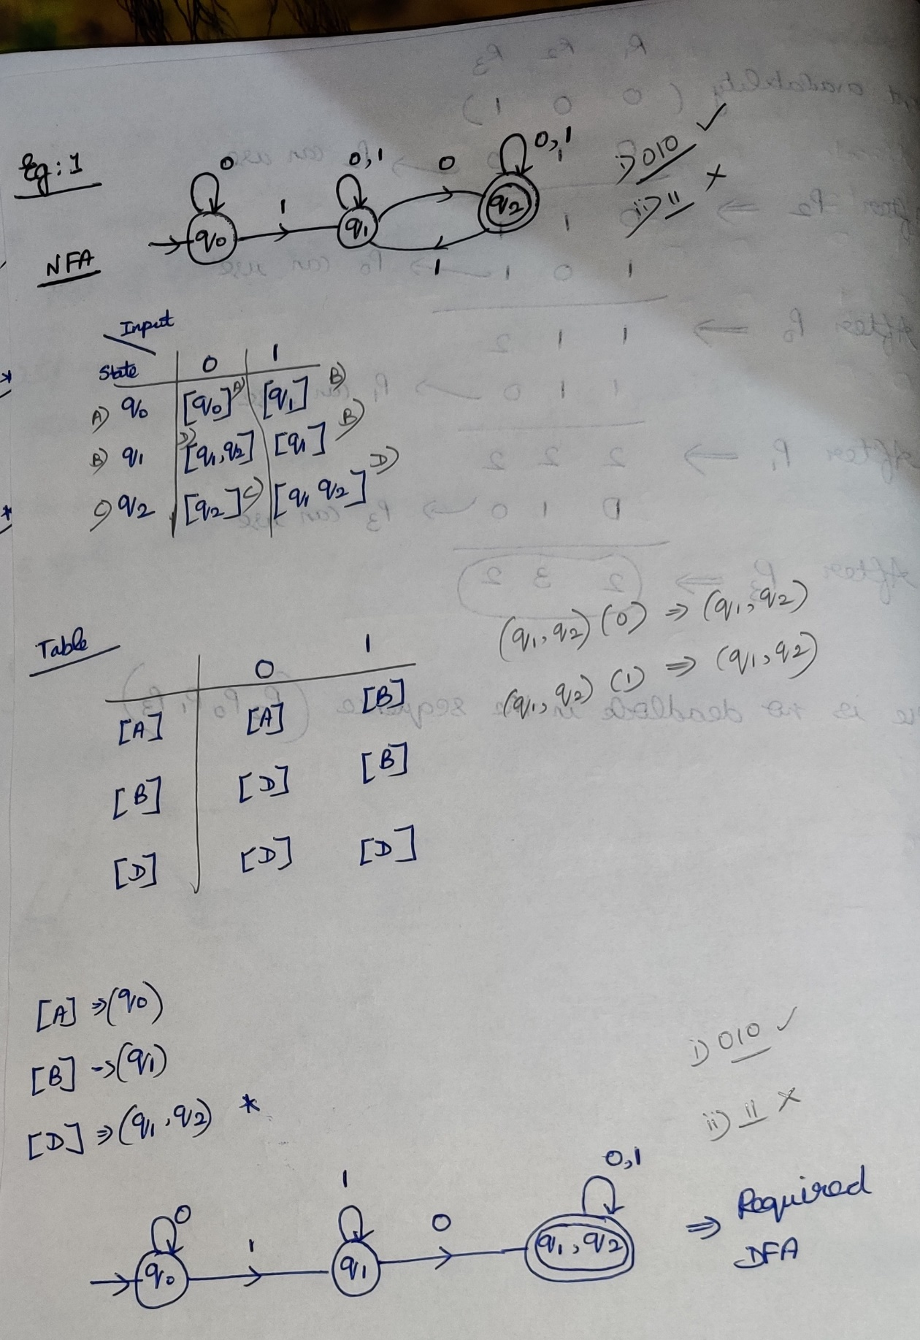

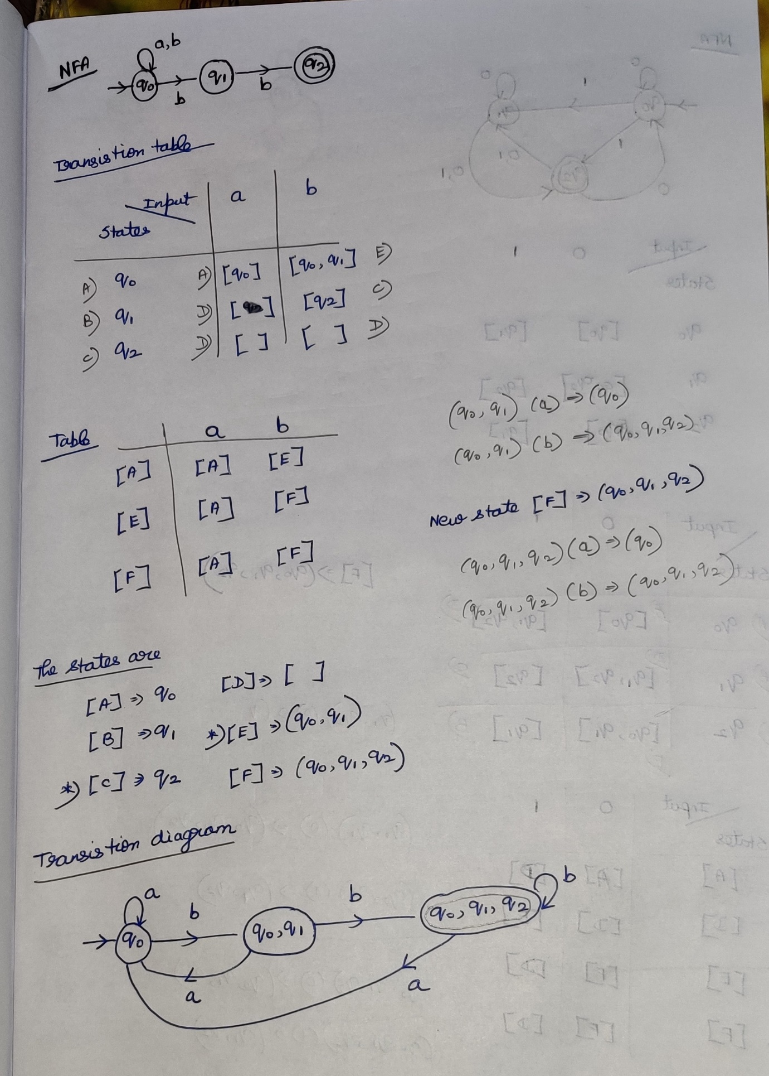

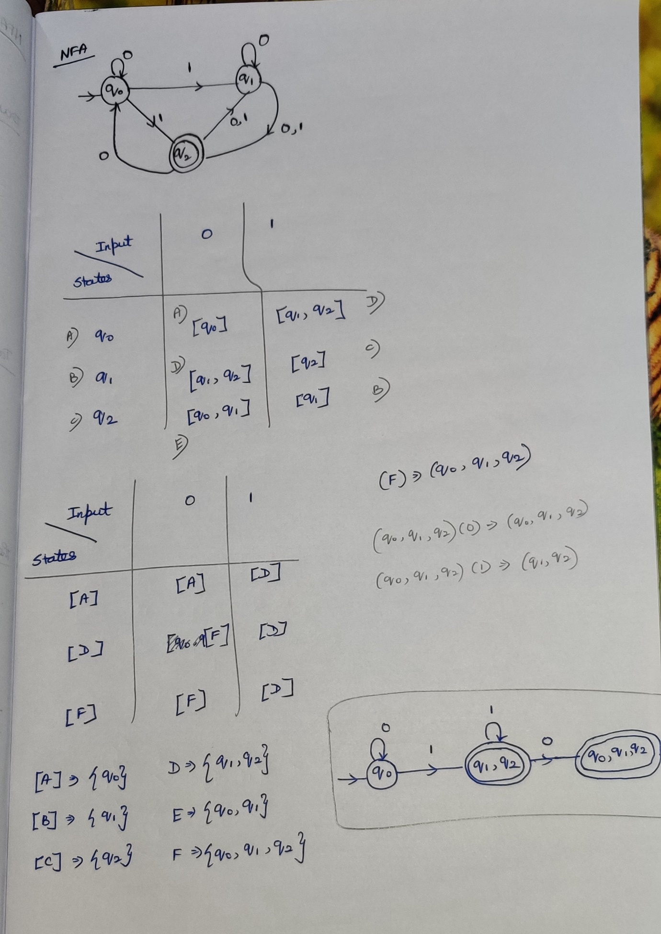

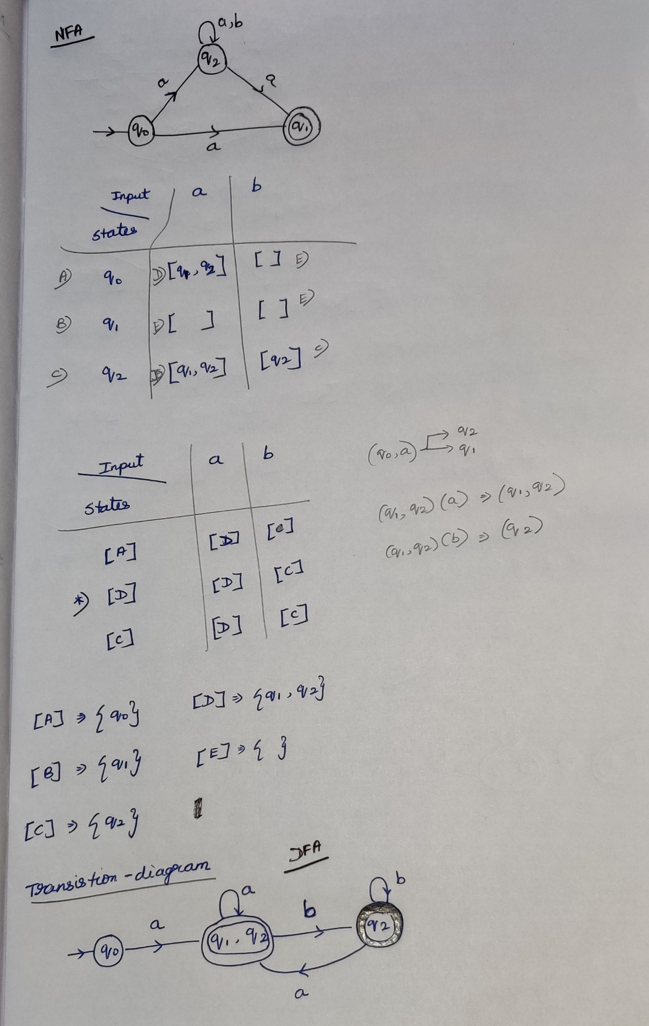

**(Convert epsilon NFA to DFA)**

